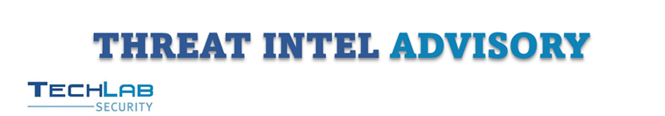
Ref:TIA250307-02
Akira Ransomware Exploits Unsecured Webcams to Evade EDR and Encrypt Networks
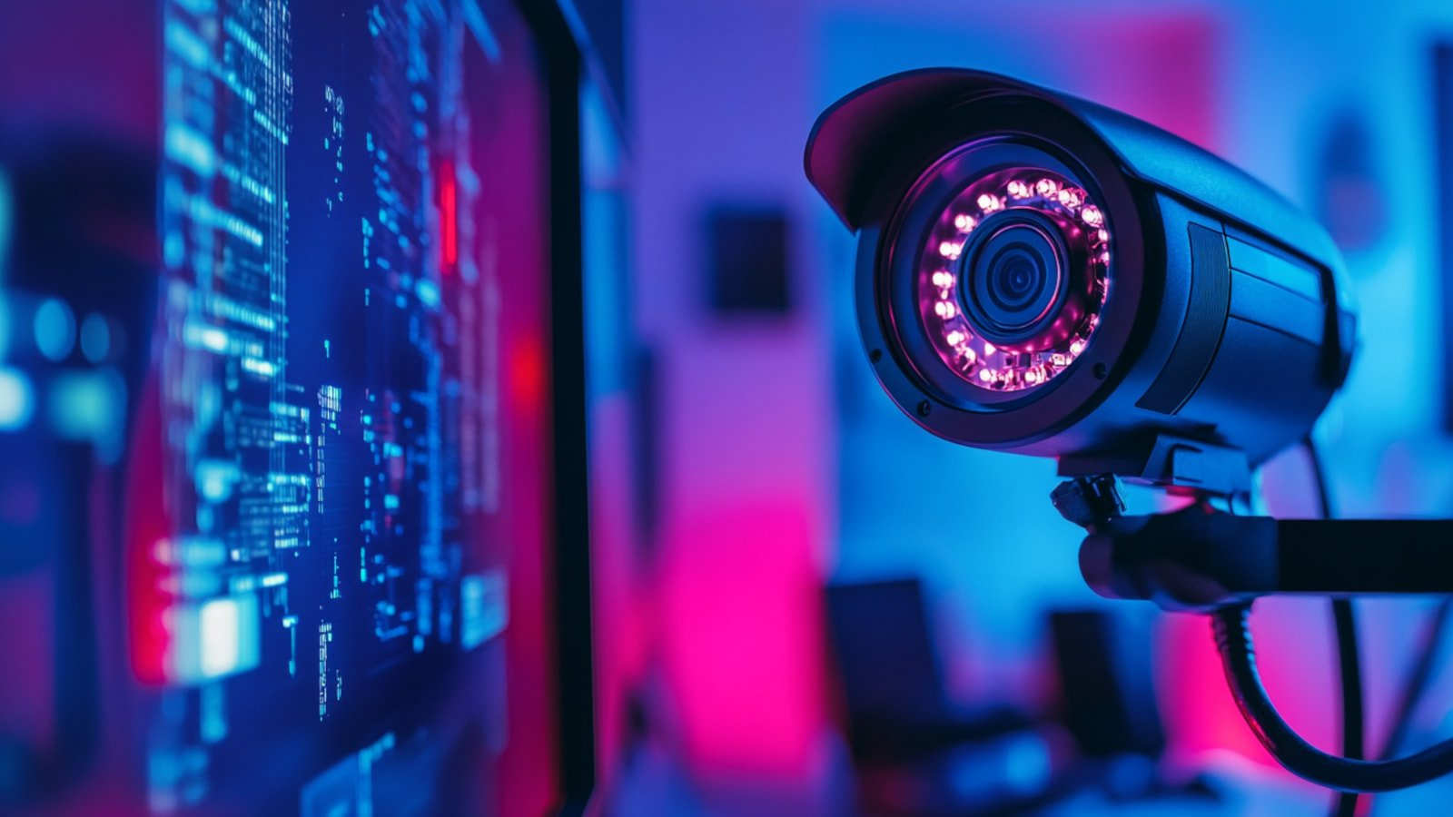
Overview | The Akira ransomware gang has recently been observed leveraging an innovative and stealthy attack vector: exploiting unsecured webcams to bypass Endpoint Detection and Response (EDR) systems and encrypt victim networks. This tactic was identified during an incident response where attackers pivoted to a vulnerable webcam after their initial ransomware deployment attempts on Windows systems were thwarted by EDR protections. By utilizing the webcam’s Linux-based operating system and its lack of EDR coverage, Akira successfully encrypted network shares over Server Message Block (SMB), demonstrating a sophisticated adaptation to modern security defences. This evolution in ransomware tactics underscores the growing need for comprehensive device security beyond traditional endpoints.
Threat Severity | High
Targeted Region | - Global
Targeted Sector | - Multiple Sectors
Attack Vector | - Initial Access: Gained through phishing or exploitation of existing vulnerabilities (exact entry unspecified in this case).  - Lateral Movement: Utilized Remote Desktop Protocol (RDP) to expand presence across the network.  - Payload Delivery Attempt: Deployed a password-protected ZIP file (win.zip) containing the ransomware executable (win.exe) on Windows systems, blocked by EDR.  - Pivot to Webcam: Shifted to an unsecured webcam with remote shell access after initial attempts failed.  - Encryption Execution: Used the webcam’s Linux OS to mount and encrypt Windows SMB network shares.
Attack Technique | The Akira ransomware gang’s use of an unsecured webcam represents a tactical evolution aimed at circumventing advanced security controls like EDR. The attack began with conventional ransomware deployment methods: after gaining initial access through phishing or unpatched vulnerabilities the attackers deployed AnyDesk, a legitimate remote access tool, to facilitate data exfiltration as part of their double-extortion strategy. They then used RDP to move laterally, attempting to maximize their reach within the victim’s network. A password-protected ZIP file containing the ransomware payload was dropped, but the victim’s EDR solution detected and quarantined it, halting the Windows-based encryption attempt.  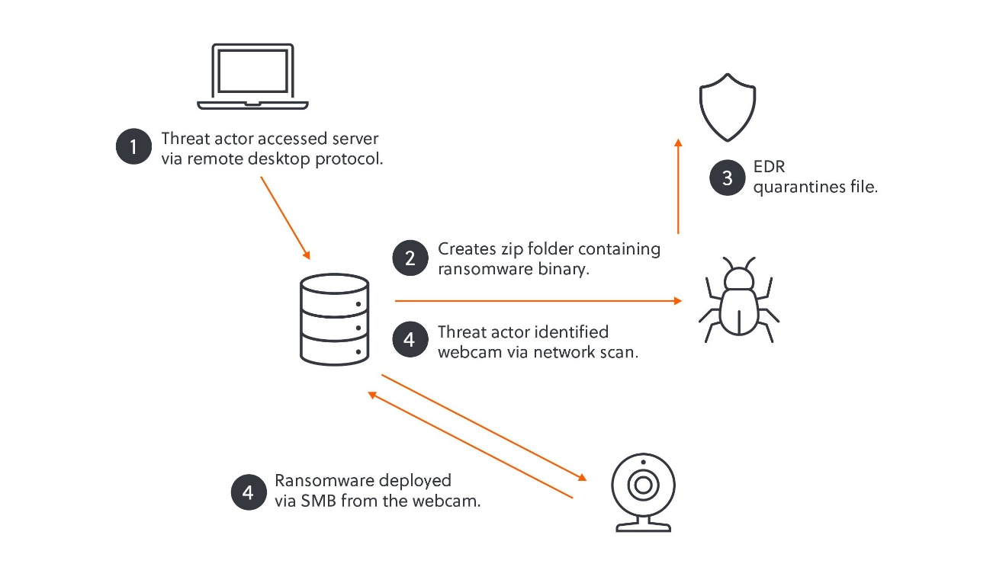  Example of Akira ransomware IoT attack chain  Undeterred, Akira pivoted to an unconventional device: a webcam running a Linux-based operating system. This device was vulnerable due to its exposure to remote shell access and lack of EDR monitoring, making it an ideal foothold. The webcam’s compatibility with Akira’s Linux encryptor allowed the attackers to mount Windows SMB network shares remotely. By executing the encryption from the webcam over SMB, they effectively bypassed the EDR protections on Windows endpoints, as the malicious activity originated from an unmonitored device. This approach highlights the gang’s adaptability and underscores the risks posed by overlooked IoT devices within enterprise networks.  The webcam’s vulnerabilities likely unpatched firmware or misconfigured settings enabled this attack vector, emphasizing the importance of securing all network-connected devices. The use of legitimate tools like AnyDesk and RDP further complicates detection, blending malicious activity with normal administrative behavior. This incident demonstrates Akira’s willingness to exploit gaps in security coverage, leveraging both technical sophistication and operational opportunism to achieve their objectives.
Mitre ATT&CK Technique
  T1190 | Phishing: Spearphishing Attachment
  T1078 | Valid Accounts
  T1021.001 | Remote Desktop Protocol
  T1059 | Command and Scripting Interpreter
  T1566 | Phishing
  T1105 | Ingress Tool Transfer
  T1048 | Exfiltration Over Alternative Protocol
  T1486 | Data Encrypted for Impact
IOCs
  SHA-1 | 3920f3c636865148e08288f8227e92c969d690e5
  SHA-1 | b5a5bd9f727623b2eeea051e1dd7d57705daa03a
  SHA-1 | ac9952bcfcecab7400e837d55f91e9a5eeb67d07
Impacts | - Encrypted files across network shares, potentially unrecoverable without decryption keys.  - Network encryption disrupts business operations, especially in critical sectors.  - Costs from ransom payments, recovery efforts, and lost productivity.  - Exfiltration of sensitive data via AnyDesk for double-extortion purposes.  - Loss of trust from customers or partners due to security failure.
Affected Products | - Windows Operating Systems  - Linux-based Webcams  - AnyDesk
Recommended Action | Techlab Threat Intelligence team highly recommends users and organization to follow the following security control categories:  Organizational Control:  - Develop and enforce policies for securing IoT devices, including regular security assessments.  - Implement network segmentation to isolate IoT devices from critical systems.  - Establish incident response plans that account for IoT device vulnerabilities.  Technological Control:  - Regularly update firmware and software on webcams and IoT devices to address known vulnerabilities.  - Deploy network monitoring tools to detect unusual activities from IoT devices.  - Configure firewalls to restrict unnecessary inbound and outbound traffic to and from IoT devices.  - Block the IOCs  People Control:  - • Provide training to staff on the risks associated with unsecured IoT devices.  - Encourage reporting of any suspicious device behaviours or network anomalies.  - Limit administrative access to IoT device configurations to authorized personnel only.  Physical Control:  - Secure physical access to IoT devices to prevent unauthorized tampering.  - Regularly inspect IoT devices for signs of physical compromise or unauthorized modifications.
References | - https://www.bleepingcomputer.com/news/security/akira-ransomware-encrypted-network-from-a-webcam-to-bypass-edr/  - https://www.s-rminform.com/latest-thinking/camera-off-akira-deploys-ransomware-via-webcam  - https://www.cyberdaily.au/security/11811-watch-this-unsecured-webcam-used-in-recent-ransomware-attack
TechLab Cyber Threat Intelligence Team is responsible for the detection of emerging cyber threats and vulnerabilities that are impacting enterprises. TechLab CTI specializes in various Threat Intelligence services that encompass active monitoring of the current threat landscape, brand monitoring, dark web monitoring, and security risk assessment to ensure potential threats are mitigated.
TechLab Cyber Threat Intelligence Team’s key responsibilities are:
- Monitor security alerts also maintain awareness of new threats and vulnerabilities to ensure potential risks are mitigated.
- Collecting data feeds and information on threats and/or vulnerabilities to enrich detection.
- Conduct investigations on potential threats to identify the malware and/or threat actor.
- Participating in Incident Response activities to identify and contain threats.
- Recommending solutions to combat emerging threats for internal and external parties.
- Conduct regular security policy audits to ensure compliance with industry standards and best practices.
- Generating cyber threat landscape trends report for internal use by management and/or external use by customers or stakeholders.



Please contact us using below email link

www.techlab.com.my soc-cti@techlab.com.my

Copyright © 2024 - TechLab Security Sdn. Bhd. All rights reserved.

DISCLAIMER
The content of this email is confidential and intended for the recipient specified in this message only. It is strictly forbidden to share any part of this message with any third party, without the written consent of the sender. If you received this message by mistake, please reply to this message and follow with its deletion, so that we can ensure such a mistake does not occur in the future. The information contained in this document is TechLab privileged and confidential information intended only for the use of the recipient above, and may not be duplicated, used, or disclosed in whole or in part for any purpose.

